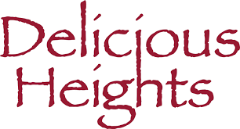

HAPPY HOUR
AVAILABLE IN BAR AREA ONLY
TUESDAY THRU FRIDAY 3-6 PM

HOUSE WINE BY THE GLASS
$8
CHARDONNAY, SAUVIGNON BLANC
PINOT GRIGIO, MERLOT, CABERNET

DOMESTIC DRAFT
$6
YUENGLING, MILLER LITE, BLUE MOON

DOMESTIC BOTTLES
$4
BUDWEISER, BUD LITE
COORS LIGHT

WELL DRINKS
$8
PRAIRIE VODKA, PRAIRIE GIN, SAUZA TEQUILA BACARDI, JACK DANIELS, DEWARS, WILD TURKEY
$3.00 Up Charge for Martini

FOOD MENU

BUFFALO WINGS
$8

CHICKEN TENDERS
PLAIN OR BUFFALO STYLE
$8

SALTED GERMAN PRETZEL
$8

MOZZARELLA STICKS
$8

